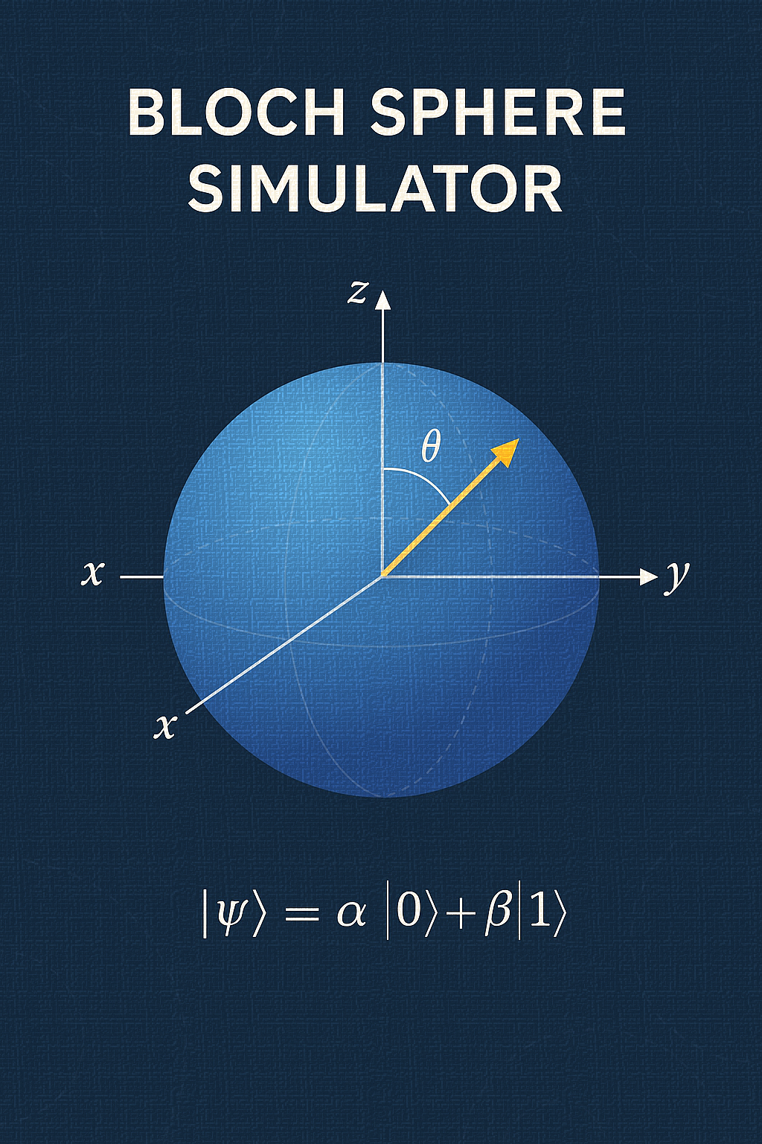

Project Proposal
Prepared for: Bacsárdi László, Prof
Prepared by: Achraf Badiry & Noor Ali Jawad Almukhtar
April 20, 2025

Bloch Sphere
1. Why a Sphere?
Imagine you’ve got a single quantum bit, or qubit. Unlike a classical bit (just 0 or 1), a qubit lives in a two-dimensional complex vector space—its state is
∣ψ⟩ = a∣0⟩ + b∣1⟩, with ∣a∣²+∣b∣²=1
where those complex numbers a and b are probability amplitudes. But working with four real numbers (real/imaginary parts of a and b) is not an easy task: one overall phase doesn’t change physics, and normalization eats up another degree of freedom. In the end, only two real parameters matter—and those fit perfectly onto the surface of a sphere.
2. From Amplitudes to Angles
We rewrite
∣ψ⟩ = cos(θ/2)*∣0⟩ + e ^{iϕ} *sin(θ/2)*∣1⟩
- θ∈[0,π] (how “north” or “south” you sit),
- ϕ∈[0,2π) (your angle around the equator).
These spherical angles map directly to a point (x,y,z) on the unit sphere by
x = sin(θ)*cos(ϕ), y = sin(θ)sin(ϕ), z = cos(θ)
giving what’s famously called the Bloch sphere, which visualizes every pure-state qubit.
3. Gates as Rotations
How quantum gates become simple rotations?
- Pauli-X flips north ↔ south: a 180° spin around the x-axis.
- Pauli-Y spins 180° around y.
- Pauli-Z rotates the equator by 180° around z.
- Hadamard is a 180° swing about the (1,0,1) axis—taking “north” to the equator at ϕ=0.
Mathematically, any single-qubit unitary U ∈ SU(2) is a rotation by some angle α about some axis n,
U=e^{−i (α/2) n⋅σ}
so, the Bloch vector simply spins.

4. Mixed States and the Bloch Ball
Real devices aren’t perfect. Noise and partial information lead to mixed states, captured by a density matrix
ρ=1/2 * (I + x*σ_{x} + y*σ_{y} + z*σ_{z})
where now ∥(x,y,z)∥≤1. Points inside the sphere represent statistical mixtures of pure states—the famous Bloch ball. As decoherence factors in, the state “shrinks” toward the center.
5. Measurement and Collapse
In quantum mechanics, the third postulate states that a qubit—prior to any observation—resides in a coherent superposition of the computational basis states ∣0⟩ and ∣1⟩. Only when a projective measurement in the Z-basis is performed does the system yield a definite classical outcome, collapsing to ∣0⟩ or ∣1⟩ with probabilities ∣a∣² and ∣b∣², respectively. Within the Bloch-sphere formalism, this measurement process geometrically corresponds to projecting the state vector onto the north pole (z=+1) or south pole (z=−1), thereby aligning it along the z-axis.
6. Why It Matters
- Teaching: The sphere makes abstract Dirac notation into a simply understandable concept.
- Design: Circuit-builders can “see” their gates as rotations.
- Debugging: In simulators, one can trace a trajectory on the sphere to spot unwanted leaks or drifts.

Sphere Simulator Survey and Program Specification

1. Survey of Existing Bloch Sphere Simulators

1.1 QuTiP: Quantum Toolbox in Python
QuTiP is a widely used open-source library for quantum dynamics and simulation. It includes a Bloch class for plotting state vectors and density matrices on a Bloch sphere using the Mayavi 3D engine.
Advantages
- Integration with Dynamics: Seamlessly plots states arising from time-dependent solvers, enabling visualization of open-system dynamics and master equations (physics.umd.edu, qutip.org).
- Multiple Data Types: Supports adding pure states, mixed states, vectors, and points in batch via methods like add_states, add_points, and add_vectors (qutip.org).
Disadvantages
- Heavy Dependencies: Relies on Mayavi for 3D rendering, which can be difficult to install and configure, and does not embed easily into Matplotlib figures (qutip.org).
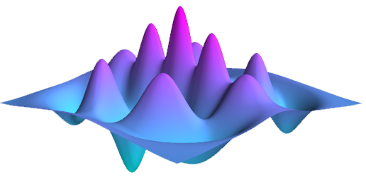
- Limited Labeling: Mayavi’s rendering engine lacks native LaTeX support, forcing users to use plain-text labels or post-process with external tools (qutip.org).

1.2 Qiskit Visualization
Qiskit, IBM’s quantum SDK, provides several functions for state visualization. Notably, plot_bloch_vector draws a single Bloch sphere, while plot_bloch_multivector renders one sphere per qubit and supports basic animation of gate sequences.
Advantages
- Matplotlib Integration: Uses Matplotlib for plotting, making it easy to customize figures and integrate with other Python scientific workflows (docs.quantum.ibm.com, docs.quantum.ibm.com).
- Ecosystem Compatibility: Directly visualizes states (Statevector, DensityMatrix) produced by Qiskit circuit simulators, fostering a smooth circuit-to-visualization pipeline (github.com).
Disadvantages
- Limited Interactivity: While Matplotlib figures can be manipulated, there is no built-in GUI for drag-and-rotate interaction; users must rely on Matplotlib’s basic 3D navigation (docs.quantum.ibm.com).
- Styling Constraints: Customizing colors and annotations often requires additional boilerplate code, as plot_bloch_vector offers only minimal parameters for fonts and figure size (quantumcomputing.stackexchange.com).


1.3 Quantum-Glasses (Qiskit Ecosystem)
Quantum-Glasses is a community-maintained, Tkinter-based GUI application for interactive Bloch sphere visualization. It sits atop Qiskit, exposing 11 single-qubit gates and live updates of the Bloch vector under gate operations.
Advantages
- Interactive GUI: Provides buttons and sliders for applying gates in real-time, aiding educational demonstrations (medium.com).
- Pre-Integrated Gates: Comes with a curated set of parameterized and non-parameterized gates, lowering the barrier for non-programmers to explore qubit rotations (medium.com).
Disadvantages
- Platform Dependency: Based on Tkinter, which can exhibit inconsistent behavior and styling across operating systems.
- Scalability: Limited to single-qubit simulations and does not support batch plotting or advanced state ensembles.

1.4 Standalone Python Packages
Several lightweight packages (e.g., blochsphere, blochpy) available via PyPI offer minimal Bloch sphere functionality: typically plotting single vectors with Matplotlib.
Advantages
- Simplicity: Minimal dependencies and straightforward APIs suit quick scripts and demos (spinquanta.com).
- Customization: Users can fork or extend basic code without navigating large codebases.
Disadvantages
- Limited Features: Often lack support for density matrices, animations, or multiple-sphere layouts.
- Maintenance: Many are community-driven projects with irregular updates and potentially outdated code.

2. Comparative Evaluation
Simulator | Rendering Engine | Integration | Interactivity | Learning Curve | Maintenance
QuTiP Bloch | Mayavi | Dynamics, Solvers | Low | Medium | High
Qiskit plot_bloch | Matplotlib | Qiskit Circuits | Low | Low | High (IBM)
Quantum-Glasses GUI | Tkinter/Matplotlib | Qiskit Gates | High | Low | Medium (Community)
Standalone PyPI tools | Matplotlib | None | Low | Very Low | Low
Key Takeaways
- For production-grade simulations of dynamics, QuTiP is unrivaled but requires heavy setup.
- Qiskit’s functions best serve quantum circuit developers already in that ecosystem.
- GUI tools like Quantum-Glasses excel in pedagogy but lack extensibility for research.
- Lightweight packages are ideal for quick demonstrations but rarely for comprehensive applications.

3. Specification of the Terminal-Based Bloch Sphere Simulator

3.1 Purpose and Scope
Develop a Python3 terminal application to:
- Accept user input for arbitrary single-qubit pure states (via Bloch angles or complex amplitudes).
- Compute and display state amplitudes, Bloch angles (θ, φ), Cartesian coordinates (x, y, z), and measurement probabilities.
- Apply elementary single-qubit gates (Pauli X, Y, Z; Hadamard).
- Render a 3D Bloch sphere plot on demand.

3.2 Functional Requirements
- State Initialization: Prompt user to select input method:
  - Angles: theta (0 to π), phi (0 to 2π).
  - Amplitudes: Complex numbers a, b, normalized automatically.
- State Conversion:
  - state_to_bloch(a, b) → (θ, φ, (x, y, z)).
  - bloch_to_state(theta, phi) → (a, b).
- Measurement: measure_state(a, b) outputs probabilities P(0), P(1).
- Gates: apply_gate(state, GATE) for GATE ∈ {X, Y, Z, H}.
- Plotting: plot_bloch_vector(x, y, z) displays a 3D sphere with vector arrow.
- Interactive Loop: REPL supporting commands {X, Y, Z, H, PLOT, SET, EXIT}.

3.3 Non-Functional Requirements
- Dependencies: numpy, cmath, matplotlib>=3.x, Python ≥3.7.
- Performance: Instantaneous replies for single-qubit operations; plotting under 2 s.
- Portability: Cross-platform (Windows, macOS, Linux). No GUI beyond Matplotlib pop-ups.
- Usability: Clear prompts and formatted numeric output with 4 decimal places.

3.4 User Interface Design
=== Bloch Sphere Simulator ===
Select input method:
1) Bloch angles (theta, phi)
2) Complex amplitudes (a, b)
Enter 1 or 2: _

Commands:
X, Y, Z, H — apply gate
PLOT — render Bloch sphere
SET — reset state
EXIT — quit
- Numeric entries validated with defaults (|0⟩ if invalid).
- Output displays amplitudes, angles, vector coords, and measurement probabilities.

3.5 System Architecture
+---------------+ +----------------+ +--------------+
| User Input | --> | Core Engine | --> | Visualization|
+---------------+ +----------------+ +--------------+
- User Input Module: Handles REPL and parsing.
- Core Engine: Implements state conversion, gate operations, measurement.
- Visualization: Encapsulates Matplotlib 3D plotting.

3.6 Data Model
- State Vector: 2-element complex NumPy array [a, b].
- Bloch Parameters: (theta: float, phi: float, x: float, y: float, z: float).

References and Credits

Wikipedia – Bloch Sphere
Cornell University – Mathematical Foundations of Quantum Computing
SpinQ - Bloch Vector Explained: Visualizing Qubit States
QuTiP – Quantum toolbox in python
ShareTechnote – Quantum Computing

